1. Status : Bug

Priority : Medium

Saverity : Moderate

Image/video:

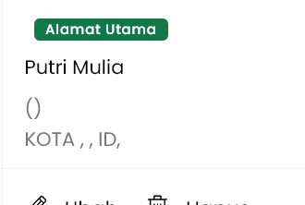

Step : 1. User create new account  
 2. User go to account page  
Current : shows data with comma (,)

Expected : if user not already set their address set as empty

1. Status : Bug

Priority : Low  
Saverity : Moderate  
Image/video:  
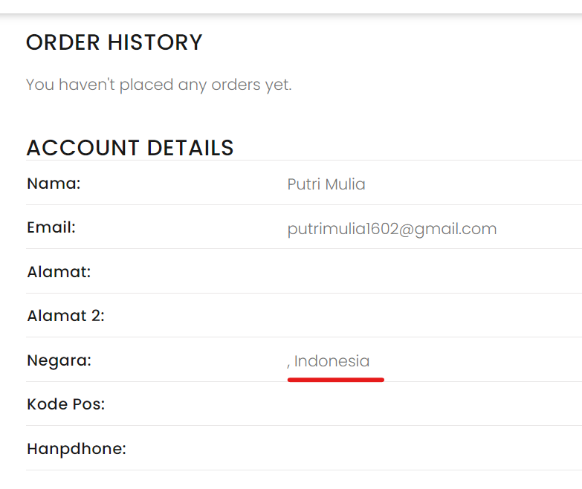

Step: 1. User login as new user  
 2. User go to account page

Current : show comma (,) in front of Indonesia

Expected : not show comma (,) in front of Indonesia

1. Status : Bug

Priority : High

Saverity : Major  
Step : 1. User login

2. User go to account page

3. User click button lihat Alamat  
 4. User click Tambah Alamat baru  
Current : Default field Provinsi is “Aceh”  
Expected : Default field Provinsi should be blank/ null when user not already set field provinsi

1. Status : Task Improvement  
   Priority : Medium

Saverity : Major  
Image/video:  
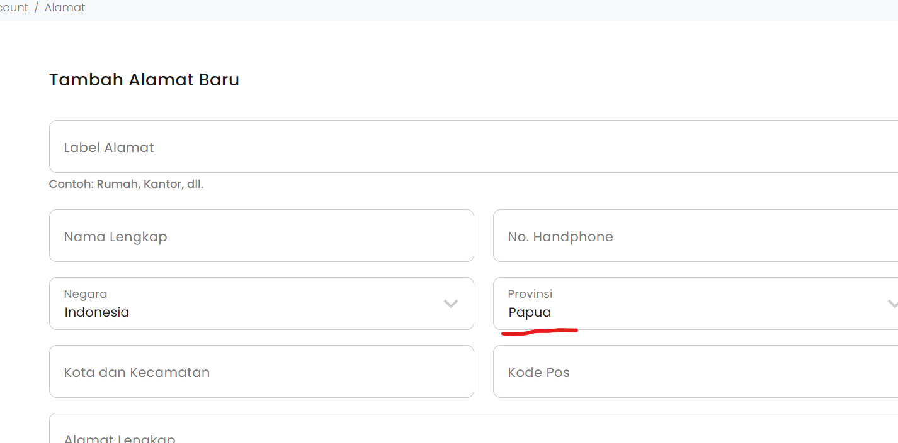  
Step : 1. User login

2. User go to account page

3. User click button lihat Alamat  
 4. User click Tambah Alamat baru  
 5. User set Provinsi “Papua”  
 6. User click button Batal  
 7. User click Tambah Alamat Baru

Current: Provinsi still set as Papua after user not save the data  
Expected : Provinsi should be set as blank when user not save the data after click Batal

1. Status : Task Improvement  
   Priority : Medium

Saverity : Low  
Image/video:  
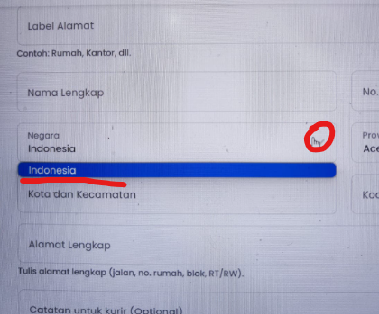  
Step: 1. User login

2. User go to account page

3. User click button lihat Alamat  
 4. User click Tambah Alamat baru  
Current : Showed icon opsi “v” on field Negara, but when user click icon opsi “v” user only see 1 opsi which is Indonesia  
Expected : Better icon opsi not showing when user only have one opsi